SafeLine: Empowering Youth Through Digital Safety and Mental Health
The SafeLine: Kamenica – Sarajevo: Digital Safety and Mental Health in Youth project, implemented by KosovaLive in partnership with Udruženje za digitalnu transformaciju (UDT BiH), brought together young people from Kosovo and Bosnia and Herzegovina to strengthen digital safety awareness, promote mental health, and encourage meaningful youth participation.
Implemented from December 2025 to June 2026 under the RYCOgnizing YPS: Meaningful Youth Participation in the Western Balkans grant scheme, the project aimed to equip young people with the knowledge and skills needed to navigate the digital world safely while building resilience and fostering cross-border cooperation.
The project officially began with a kick-off meeting in Kamenica, bringing together project partners, representatives from the Municipality of Kamenica, the Directorate of Education, schools, psychologists, educators, and young people to establish a shared vision and strengthen local partnerships.
A key component of the project was a series of Digital Safety and Mental Health Workshops held in Kamenica and Sarajevo. Through interactive training sessions, practical exercises, case studies, and peer-learning activities, 60 young people gained practical knowledge on cyber security, online privacy, cyberbullying prevention, emotional resilience, and healthy digital habits. Post-training assessments showed that 100% of participants improved their understanding of digital safety and mental health, demonstrating the project's strong educational impact.
The project also organized a cross-border Youth Exchange, where young participants from Kosovo and Bosnia and Herzegovina collaborated through intercultural learning, study visits, group discussions, and policy development sessions. Together, they co-created a Digital Safety and Mental Health Toolkit and developed a Youth Policy Brief containing practical recommendations for improving youth wellbeing and online protection. These youth-led documents were officially presented to the Municipality of Kamenica and the University of Sarajevo, strengthening dialogue between young people and institutions.
To further amplify young voices, participants designed and implemented a youth-led awareness campaign across social media. Through videos, interviews, educational posts, and digital storytelling, they promoted responsible online behavior, cyberbullying prevention, and mental health awareness. The campaign reached more than 16,000 people online, while generating hundreds of interactions and encouraging peer-to-peer learning across both countries.
The project placed a strong emphasis on inclusion and gender equality. Women and girls represented 67% of all youth participants, significantly exceeding the project's target for female participation. Young people from rural communities and underserved areas were actively included, ensuring equal access to learning opportunities regardless of geographical or economic barriers.
Beyond its immediate activities, SafeLine strengthened cooperation between civil society organizations, educational institutions, local authorities, and youth. It empowered young people to become active contributors to safer digital communities while supporting the localization of the Youth, Peace and Security (YPS) agenda through meaningful youth participation, dialogue, and cross-border collaboration.
By combining education, youth leadership, policy engagement, and regional cooperation, SafeLine has created lasting resources and partnerships that will continue supporting young people in building safer, healthier, and more inclusive digital environments.

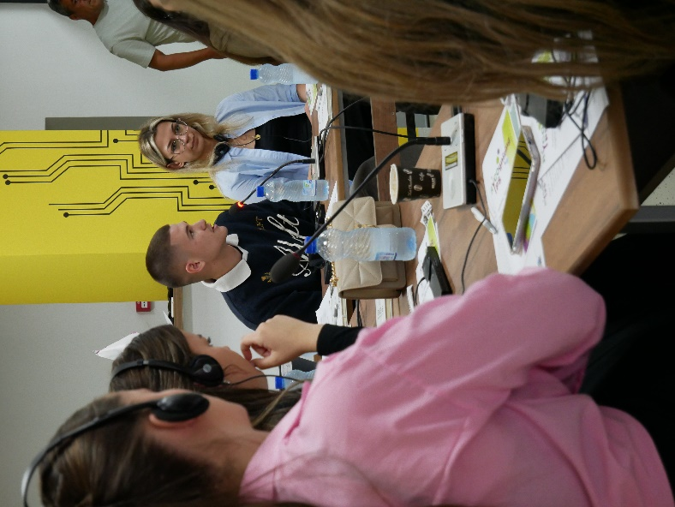
Ari Thaci - Privatesia eshte fuqi. Duke mbrojtur veten online, ne po kujdesemi direkt direkt për shendetin tonë mendor dhe sigurine tonë. Përshtypjet e mija për këtë projekt janë shumë të mira, sepse kmei mësuar si të mbrojmë vetën dhe të tjerët në hapsirë dixhitale, diçka shumë e rëndësishme me të cilën ballafaqohemi çdo ditë si shoqëri.

